[![Review Assignment Due Date](https://classroom.github.com/assets/deadline-readme-button-24ddc0f5d75046c5622901739e7c5dd533143b0c8e959d652212380cedb1ea36.svg)](https://classroom.github.com/a/vbnbTt5m)

[![Open in Visual Studio Code](https://classroom.github.com/assets/open-in-vscode-718a45dd9cf7e7f842a935f5ebbe5719a5e09af4491e668f4dbf3b35d5cca122.svg)](https://classroom.github.com/online_ide?assignment_repo_id=15232907&assignment_repo_type=AssignmentRepo)

# Dev_Setup

Setup Development Environment

#Assignment: Setting Up Your Developer Environment

#Objective:

This assignment aims to familiarize you with the tools and configurations necessary to set up an efficient developer environment for software engineering projects. Completing this assignment will give you the skills required to set up a robust and productive workspace conducive to coding, debugging, version control, and collaboration.

# Tasks:

**1. Select Your Operating System (OS):**

Choose an operating system that best suits your preferences and project requirements. Download and Install Windows 11. https://www.microsoft.com/software-download/windows11

* Checking for Compatibility

a) Download and run the PC Health Check here (aka.ms/GetPCHealthCheckApp). This is the official, Microsoft-developed application to check if your PC meets all the hardware requirements to update.

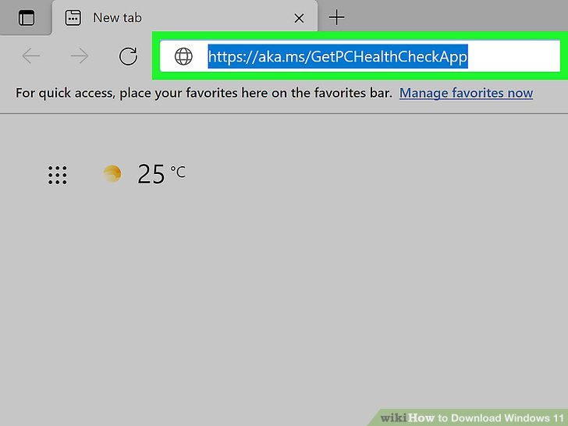

b) Run the app after it has completed installation, and click Check now.

If your PC meets the requirements, it should display a green checkmark stating that your PC is compatible.

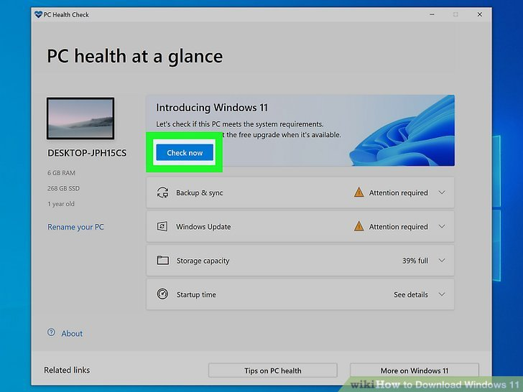

c) Back up your PC just in case. Your upgrade to Windows 11 should be smooth and seamless, but just if something goes wrong, backing up will ensure you don't lose any of your files.

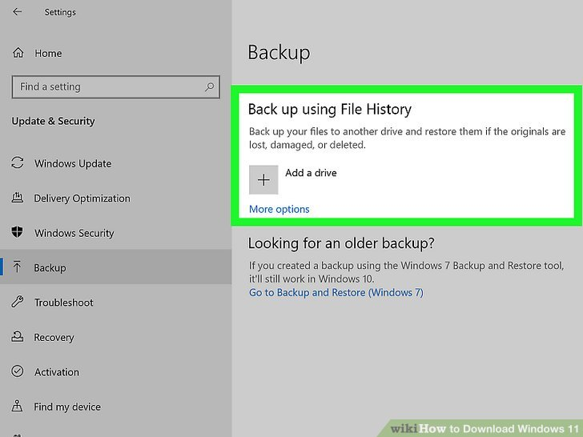

* Upgrading via Settings

a) This is the standard upgrade process that you would use to upgrade your Windows 10 to Windows 11.

Open "Update and Security" in Settings. Use ⊞ Win+I, or head to your Start menu, click the gear icon to open Settings, and then click on the "Update and Security" tab.

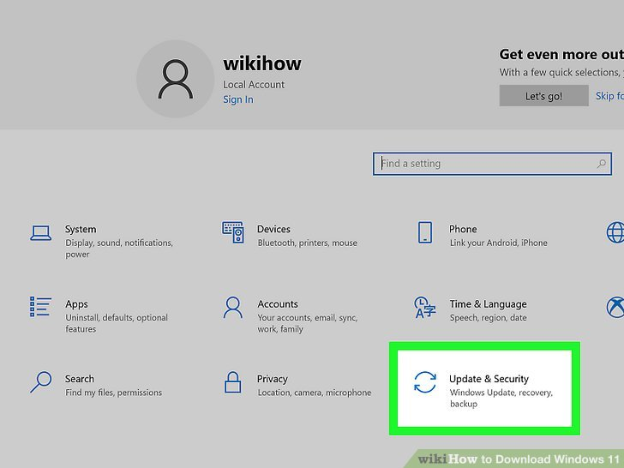

b) Click Download and install on the Windows 11 menu. It should be a blue background that notifies you that your PC is ready.

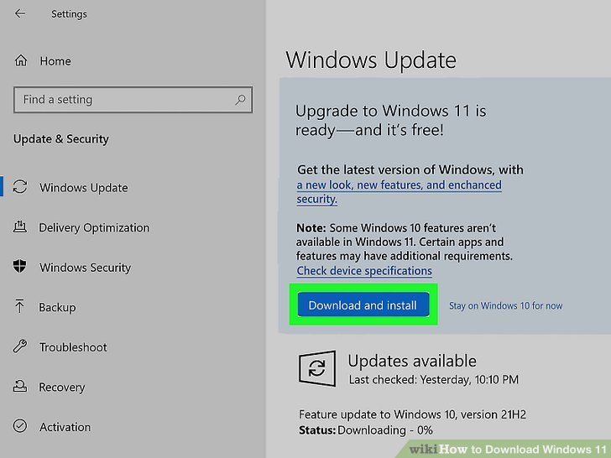

c) Follow through with the download process! You'll be prompted with a license agreement, which you need to accept. Then, a window will pop up, in which the download will take place.

The three steps that will take place in the download window will be "Downloading," "Verifying Download," and lastly "Installing." This process can take up to a few hours depending on your PC and internet connectivity.

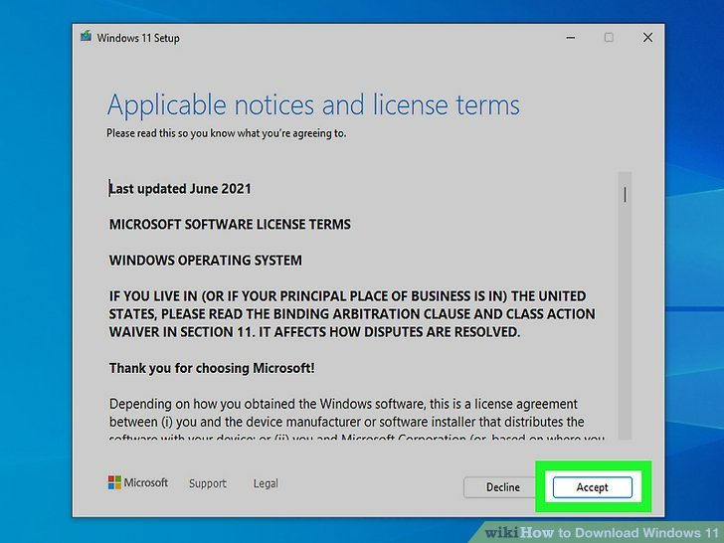

d) Restart your PC. After it is done installing, the window will prompt you to restart your PC and start a countdown of 30 minutes. Simply hit "Restart now."

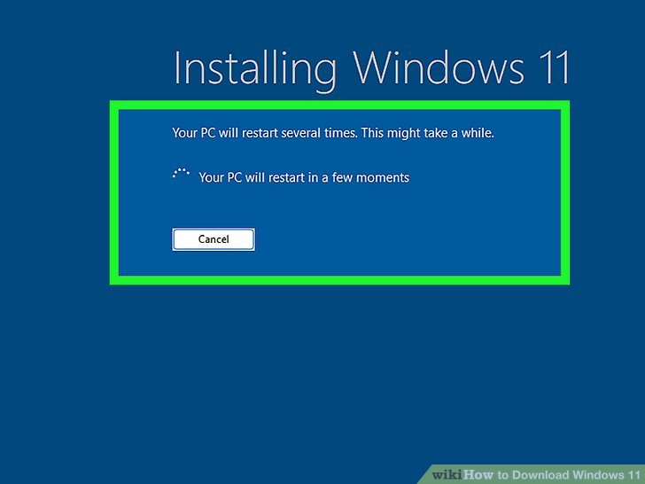

Let your PC run the installation process. Your computer will automatically run the installation process.

Do not shut down your computer, and be sure to keep it plugged in throughout the process.

e) Complete! Once Windows 11 has finished installing, you'll be brought to the Windows 11 start-up screen like normal. Log in as you normally would and start exploring the new features of Windows 11.

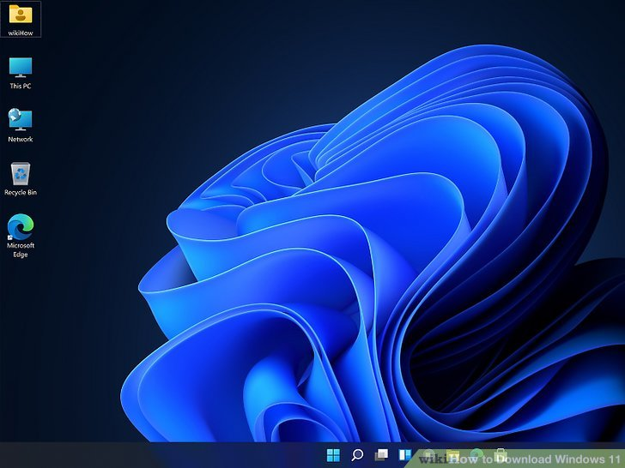

**2. Install a Text Editor or Integrated Development Environment (IDE):**

Select and install a text editor or IDE suitable for your programming languages and workflow. Download and Install Visual Studio Code. <https://code.visualstudio.com/Download>

* Open Google and type **Visual Studio Code download** in the search bar.

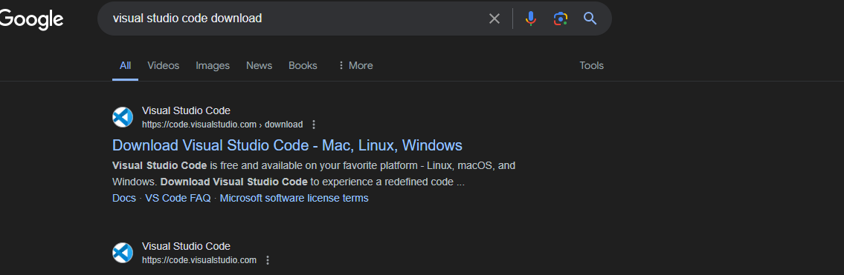

* Now, select the respective OS. In this case we are selecting Windows.

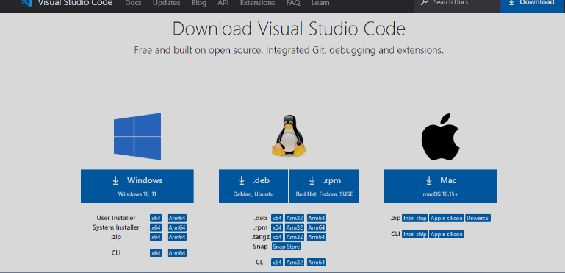

* The file will be downloaded onto your system. Open the file and then click on Install. After downloading the VS Code file, the official site will display a Thanks message for downloading the file.

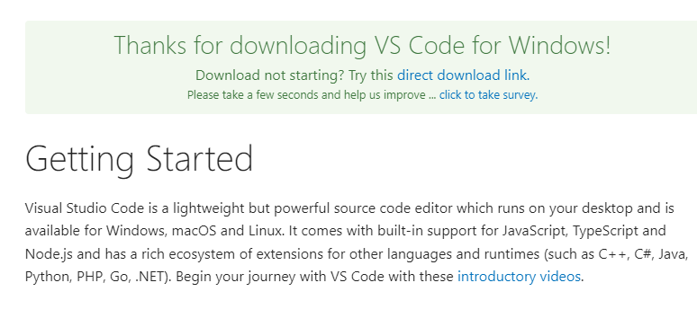

* Now accept the license agreement.

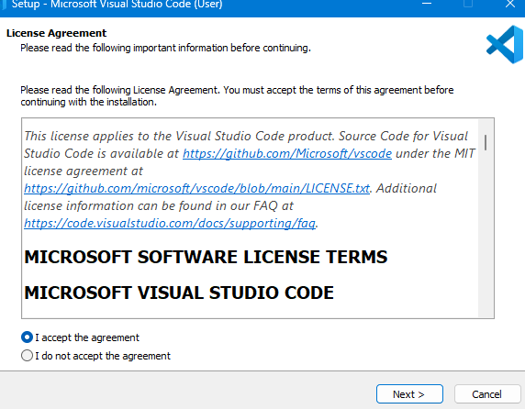

* Then it prompts for the file location, where you want to save the VS Code file. Browse the location and then click on Next.

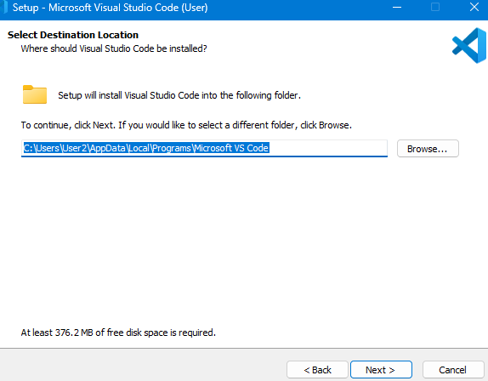

* Next, you see the prompt for the additional task which we want the VS Code to perform. At this step, choose the default settings and then click on next.

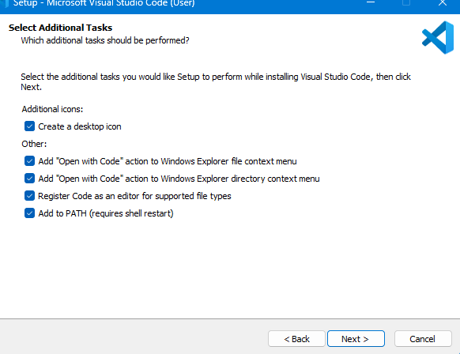

* The next prompt is how you want the VS Code on your startup. Change according to your convenience and click on Next.

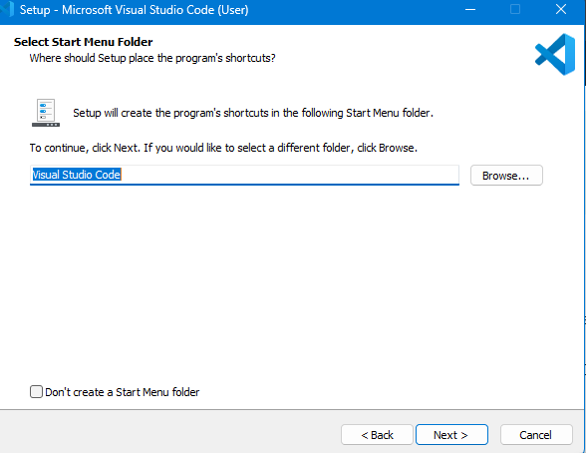

* The setup is now ready to begin installing visual studio code. Click install

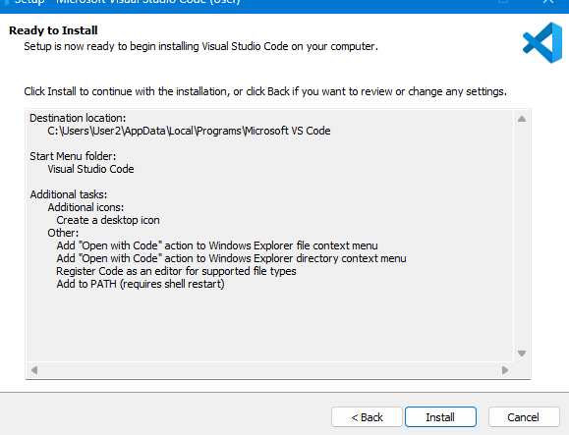

* The installation of VS Code will now begin.

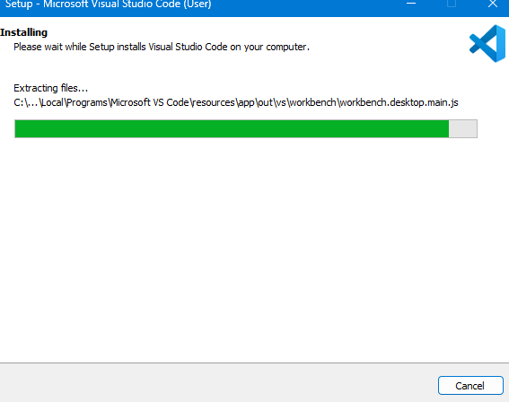

* At this step, we have completed installing VS Code, click on Finish.

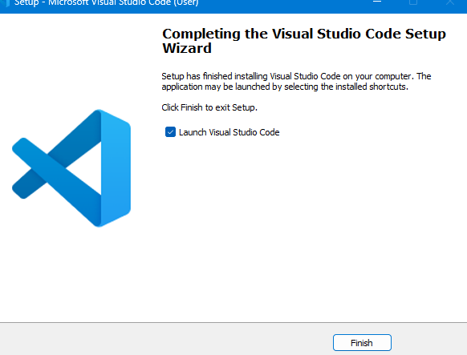

**3. Set Up Version Control System:**

Install Git and configure it on your local machine. Create a GitHub account for hosting your repositories. Initialize a Git repository for your project and make your first commit. <https://github.com>

* 1. Install Git in Windows

Download Git from the official Git website: <https://git-scm.com/download/win>

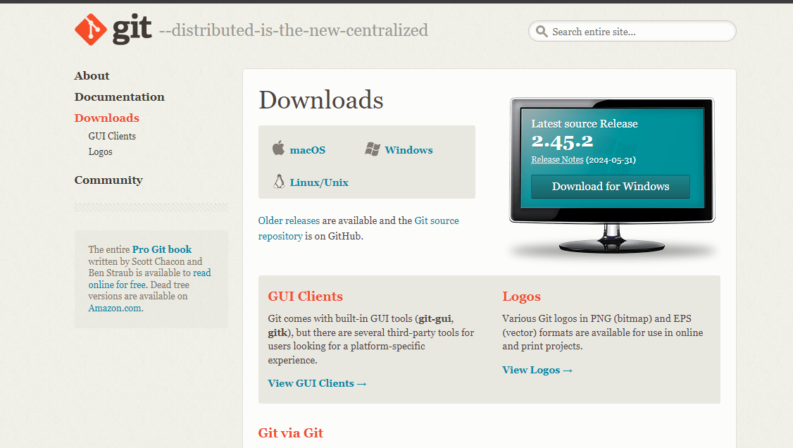

* Click on Windows

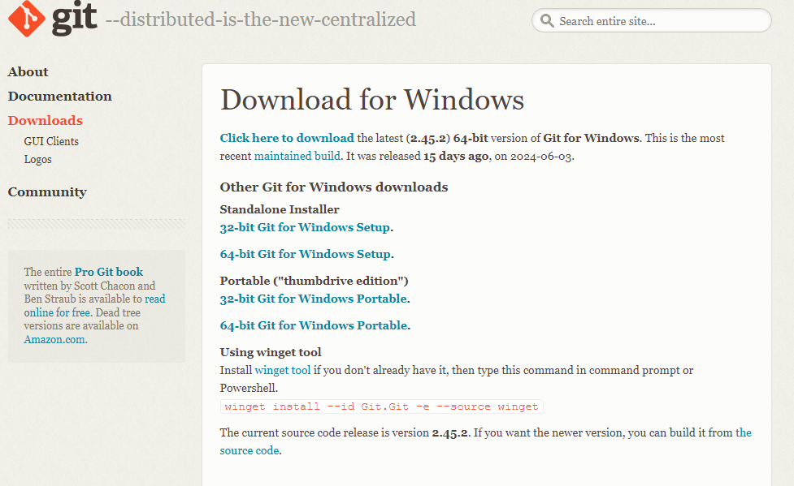

* Navigate to [Click here to download] to download the latest version and select the location to save it

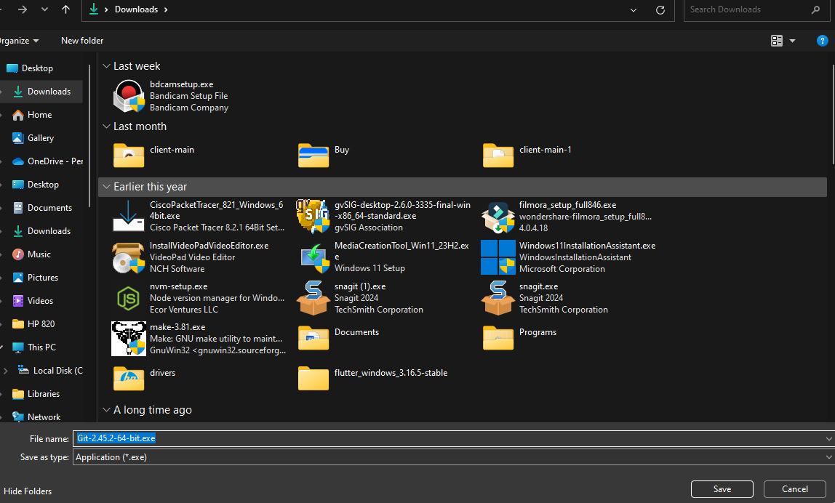

* Run the installer and follow the setup instructions.

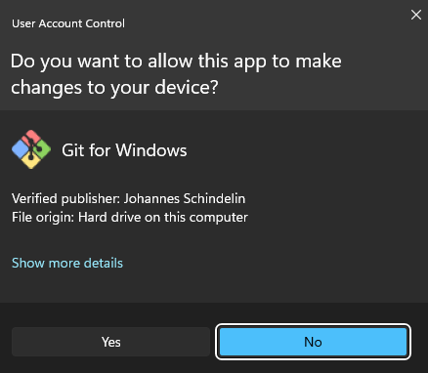

* Read the terms and conditions and then click install

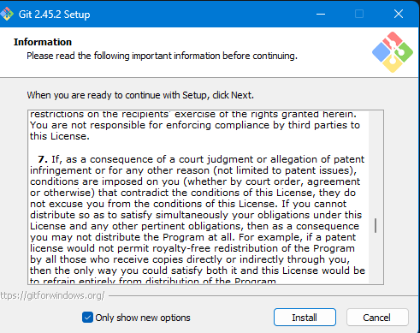

* The setup is installing git on your computer

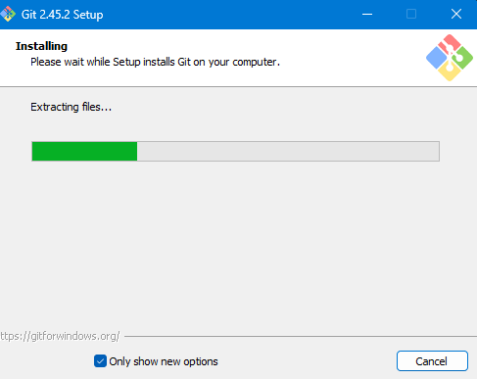

* Launch and click finish to open git bash

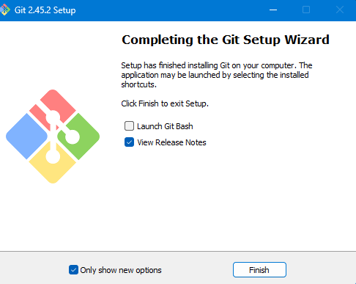

* On Git Bash Set your username and email for Git:

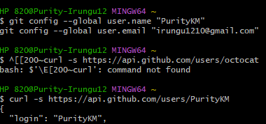

* Visit <https://github.com> Signup and follow instruction to create an account

Initialize a Git Repository

* Navigate to your project directory in the terminal:

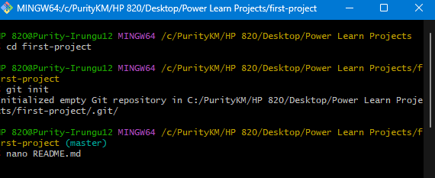

* Make your first commit

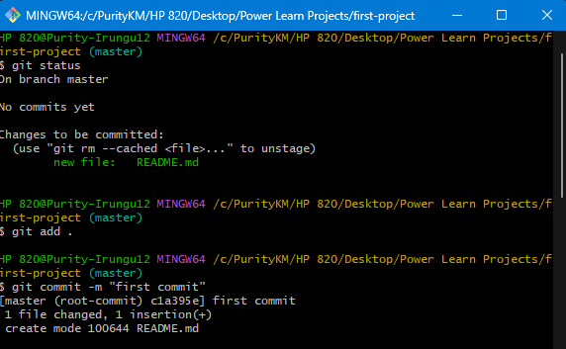

**4. Install Necessary Programming Languages and Runtimes:**

Install Python from http://wwww.python.org programming language required for your project and install their respective compilers, interpreters, or runtimes. Ensure you have the necessary tools to build and execute your code.

* Go to the official Python website: <https://www.python.org/downloads/>
* Download the latest stable version of Python for your operating system.

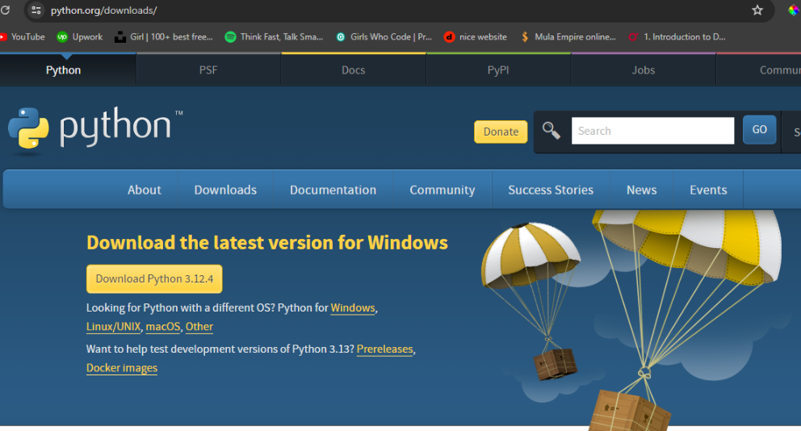

* Run the downloaded installer. During installation, make sure to check the box that says "Add Python to PATH" to ensure Python is accessible from the command line. Follow the installation steps provided by the installer.

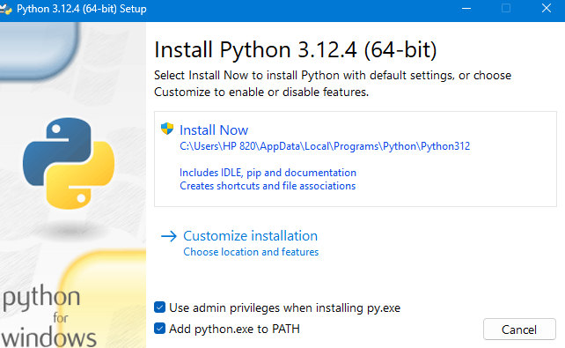

* The setup is installing on your computer

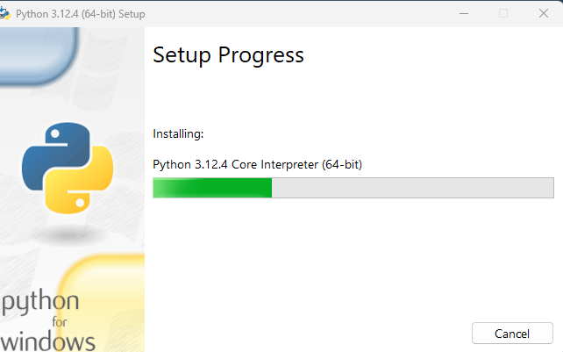

**5. Install Package Managers:**

If applicable, install package managers like pip (Python) and Django

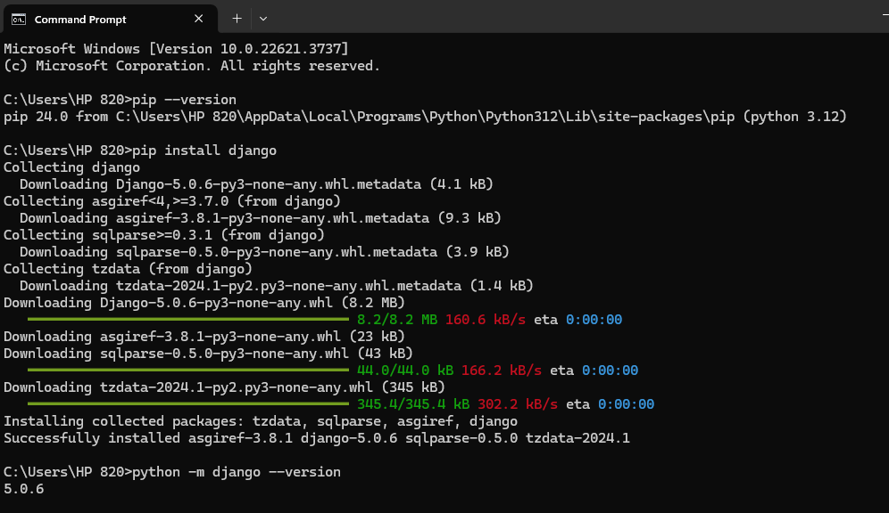

**6. Configure a Database (MySQL):**

Download and install MySQL database. <https://dev.mysql.com/downloads/windows/installer/5.7.html>

* Go to the MySQL Community Downloads page: MySQL Community Downloads

Select the appropriate installer version. For most users, the "MySQL Installer for Windows" is suitable. Click on the "Download" button to download the installer.

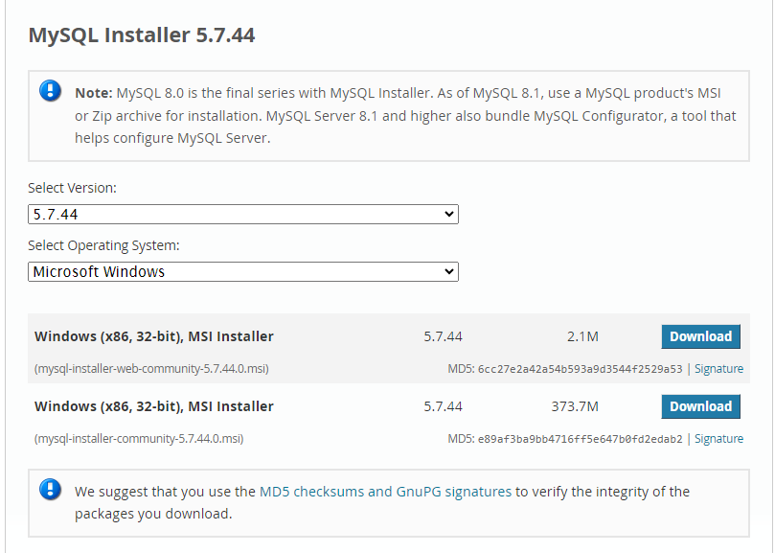

* Once downloaded, run the MySQL installer executable (.exe file).

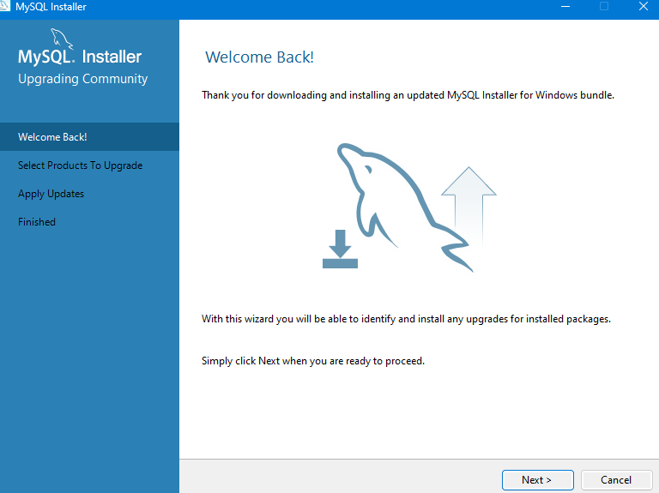

* Click on execute

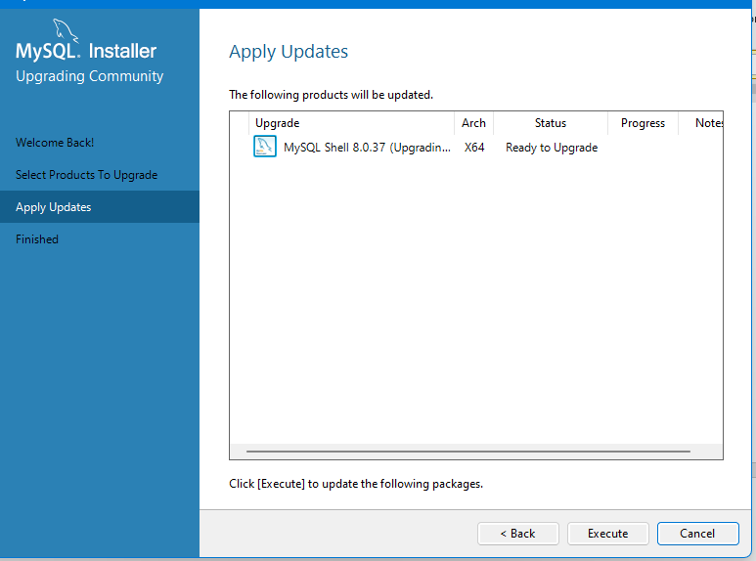

* MySQL Router Configuration. You can change the port number. Click Finish

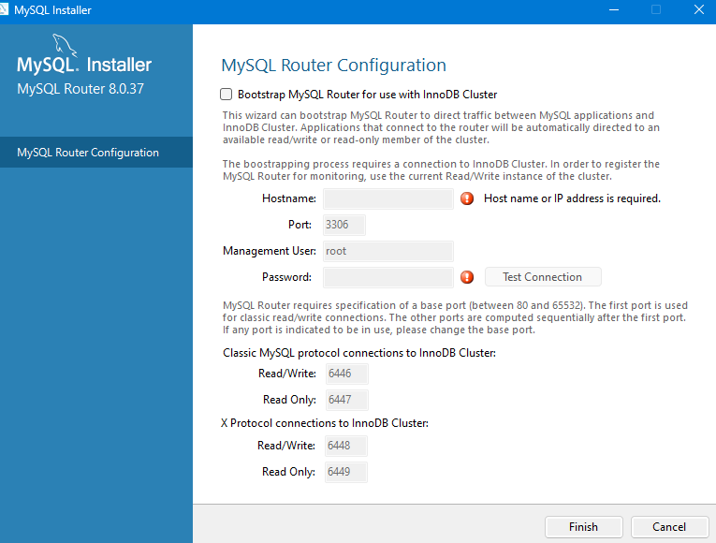

**7. Set Up Development Environments and Virtualization (Optional):**

Consider using virtualization tools like Docker or virtual machines to isolate project dependencies and ensure consistent environments across different machines.

* Go to the Docker website: <https://www.docker.com/get-started>. Download and install Docker Desktop for your operating system.

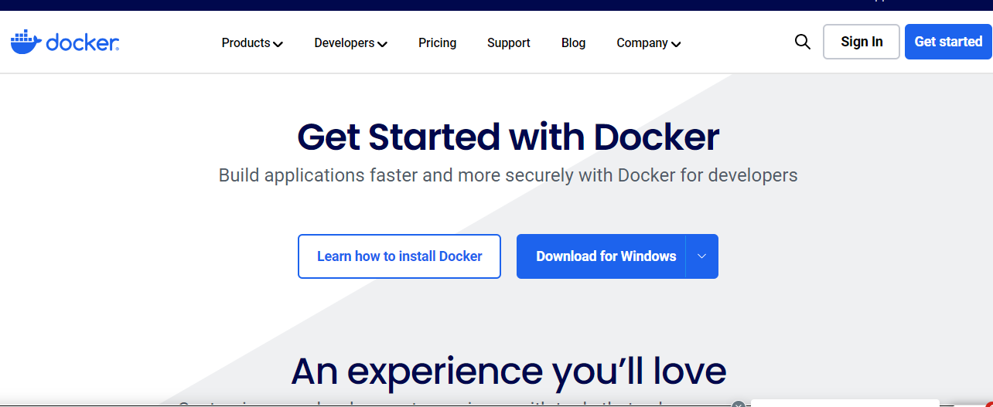

* Initializing and verifying packages

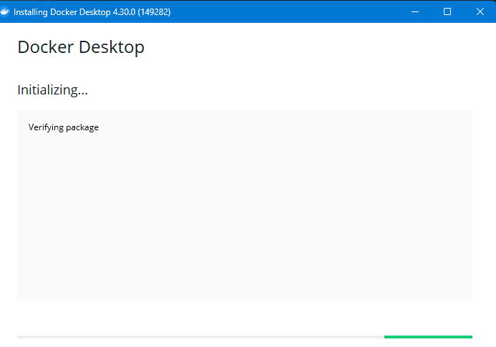

* Unpacking the files.

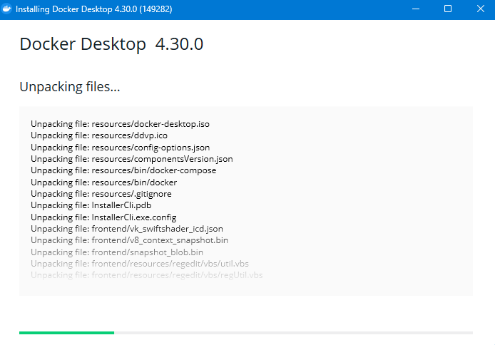

**8. Explore Extensions and Plugins:**

Explore available extensions, plugins, and add-ons for your chosen text editor or IDE to enhance functionality, such as syntax highlighting, linting, code formatting, and version control integration.

### Visual Studio Code (VS Code)

VS Code is known for its extensive library of extensions that cater to almost every development need.

1. **Syntax Highlighting**

* **Python**: Python

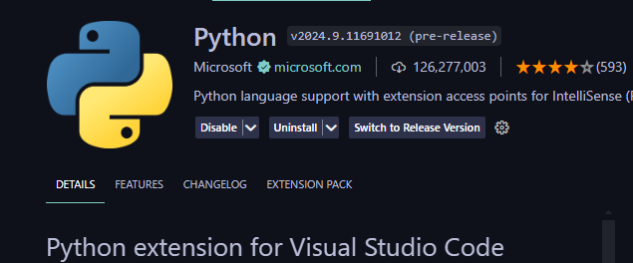

* **JavaScript/TypeScript**: [JavaScript (ES6) code snippets](https://marketplace.visualstudio.com/items?itemName=xabikos.JavaScriptSnippets)

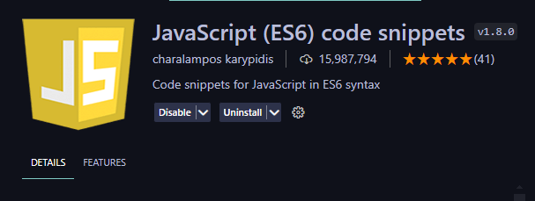

* **HTML/CSS**: [HTML CSS Support](https://marketplace.visualstudio.com/items?itemName=ecmel.vscode-html-css)

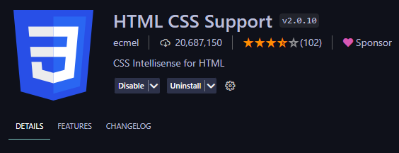

1. **Linting**

* **ESLint**: [ESLint](https://marketplace.visualstudio.com/items?itemName=dbaeumer.vscode-eslint)

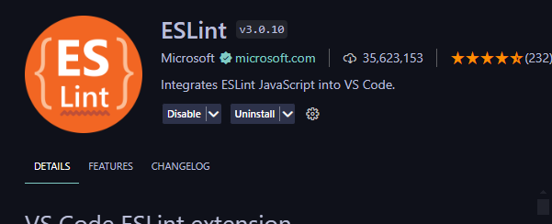

* **Pylint**: [Python](https://marketplace.visualstudio.com/items?itemName=ms-python.python)

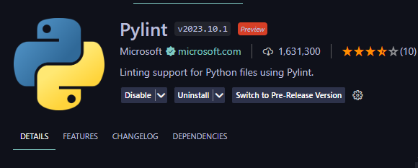

1. **Code Formatting**

* **Prettier**: [Prettier - Code formatter](https://marketplace.visualstudio.com/items?itemName=esbenp.prettier-vscode)

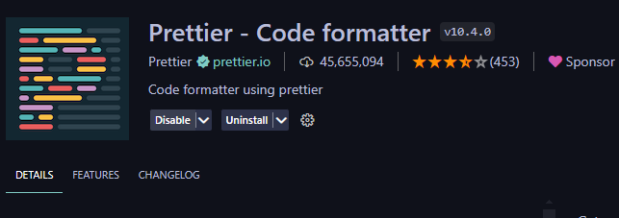

* **Beautify**: [Beautify](https://marketplace.visualstudio.com/items?itemName=HookyQR.beautify)

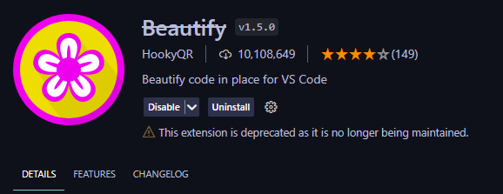

1. **Version Control Integration**

* **GitLens**: [GitLens - Git supercharged](https://marketplace.visualstudio.com/items?itemName=eamodio.gitlens)

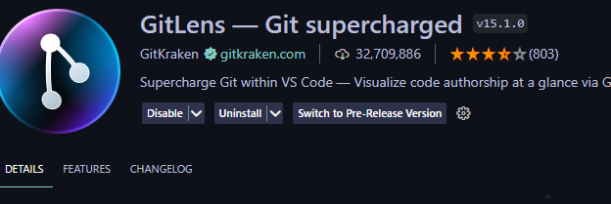

* **GitHub**: [GitHub Pull Requests and Issues](https://marketplace.visualstudio.com/items?itemName=GitHub.vscode-pull-request-github)

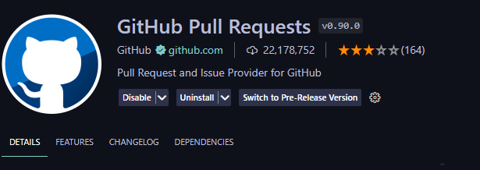

**9. Document Your Setup:**

Create a comprehensive document outlining the steps you've taken to set up your developer environment. Include any configurations, customizations, or troubleshooting steps encountered during the process.

#Deliverables:

- Document detailing the setup process with step-by-step instructions and screenshots where necessary.

- A GitHub repository containing a sample project initialized with Git and any necessary configuration files (e.g., .gitignore).

- A reflection on the challenges faced during setup and strategies employed to overcome them.

#Submission:

Submit your document and GitHub repository link through the designated platform or email to the instructor by the specified deadline.

#Evaluation Criteria:**

- Completeness and accuracy of setup documentation.

- Effectiveness of version control implementation.

- Appropriateness of tools selected for the project requirements.

- Clarity of reflection on challenges and solutions encountered.

- Adherence to submission guidelines and deadlines.

Note: Feel free to reach out for clarification or assistance with any aspect of the assignment.